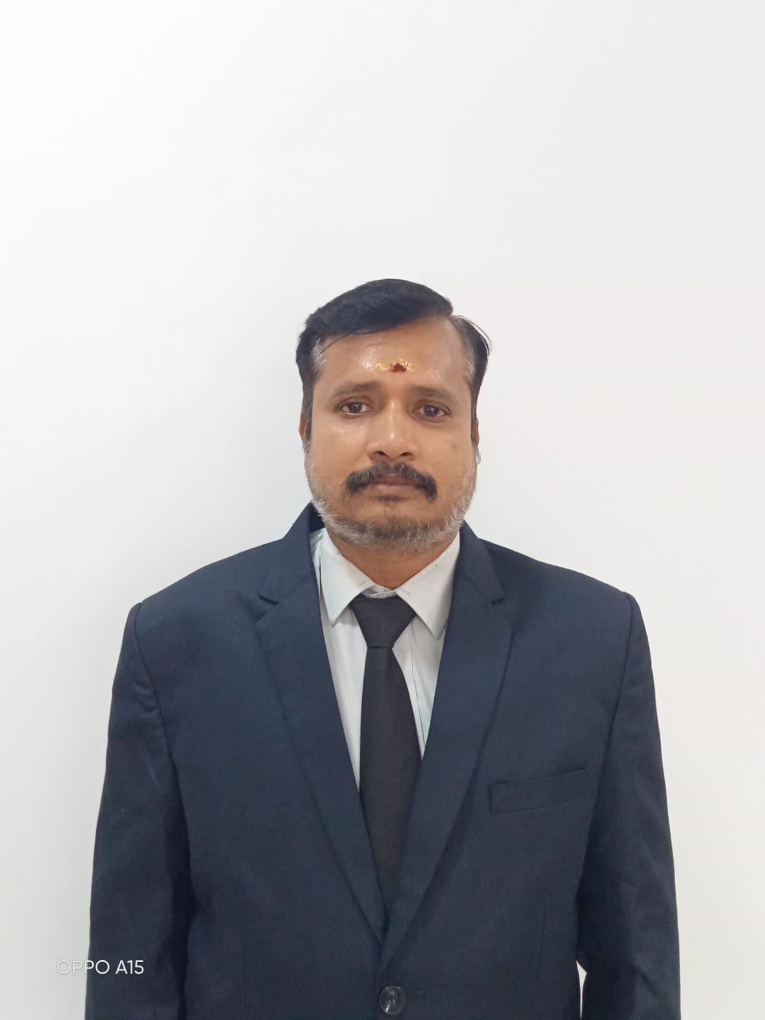

V.JAYARAMAN

Mobile: 9585458442 Email: gvjayaraman@gmail.com

Career Objective:

To grow as an innovative Hotelier through professionalism, performance, hard work and play in an active role in the enthusiastic team, working towards the betterment of the organization.

Working Experience:
- Working as an Assistant Professor in Jamal Mohamed College, Trichy
(June 2023 to till date)
- Worked as a Head of the department in Amazing institute of hotel management, Thanjavur (Mar 2022 to May 2023)
- Worked as a Head of the department in Annamal institute of Hotel Management, Thanjavur (April 2019 to Feb 2022)
- Worked as a Head of the department in Amazing institute of hotel Management, Thanjavur (June 2015 to Mar 2019)
- Worked as a Restaurant Manager in Dhaya Restaurant, Thanjavur (Since Nov 2011 to May 2015).
- Worked as a Assistant Professor in hotel Management department in JJ College of Arts & Science, Pudukkottai (Since July 06, 2010 to October 31, 2011).
- Worked as a Lecturer in Food & Beverage service department in The Bherry’s institute of Technologies, Kanchipuram (Since March09, 2007 to July02, 2010).
- Worked as Restaurant Manager in Hotel Baboo Soorya, Kanchipuram (Since July15, 2005 to March 5,2007)
- Worked as Front office Assistant in Front Office department in T.M.Hotel’s Pvt ltd, Kanchipuram (Since June 5, 2002 to July 10, 2005).

Educational Qualification:

- M.Sc., Hotel Management, (Distance Education) Annamalai University, Chidambaram 2009 – 2011.
- Diploma in Hotel Management and Catering Technology, (3 Years) Under State board of Technical Education & Training in Canan School of Hotel Management and Catering Technology, Chennai, 1999 – 2002, 58%.
- Higher Secondary (State Board), Pachaiyapppa’s Higher Secondary School, Kanchipuram, 1997 – 1999, 60%
- S.S.L.C (State Board), Pachaiyapppa’s Higher Secondary School, Kanchipuram, 1996 – 1997, 73%.

Project Profile:

“Flower Arrangements Plays a vital role in Hotel Industry – A Survey”
- To Study the effectiveness of Flowers & Flower Arrangements plays a vital role in Hotel Industry.

Computer Proficiency:

- Operating System & Package : Windows, Ms Office
- Software Languages : HMS, PMS

Extra & Co Curricular Activities:

- Weekend out door catering in all Star hotels in Chennai.
- Special out door catering in Hotel ambassador Pallava, chennai (From January 6, 2000 to January 9, 2000).
- Six Months Industrial Exposure Training in Hotel Sinclari’s Bay view, Andaman Island (May 2000 to October 2000)
- Best Attendence Award for Full Academic Year (1999 to 2002)
- Six Months HRD Course done in CLHRD (June 2001 to October 2001)

Personal Profile:

Fathers Name : Varadharajan.G
Age : 40 Years
Date of Birth : 02.03.1982
Sex : Male
Nationality : Indian
Passport No : B 3671653
Languages Known : English, Tamil (Read, Write, Speak)
Telugu, Hindi (Speak Only) French (Read, Write Only)
Marital Status : Married
Permanent Address : No -42/43, Rajappa Nagar 4th Street,
Medical College Road, Thanjavur – 613 007

Declaration:

I hereby confirm that the information given above is true to the best of my Knowledge.

[V. JAYARAMAN]

